The Bailey Group Chartered Accountants Celebrate Success at the IRIS Customers Awards Ceremony!
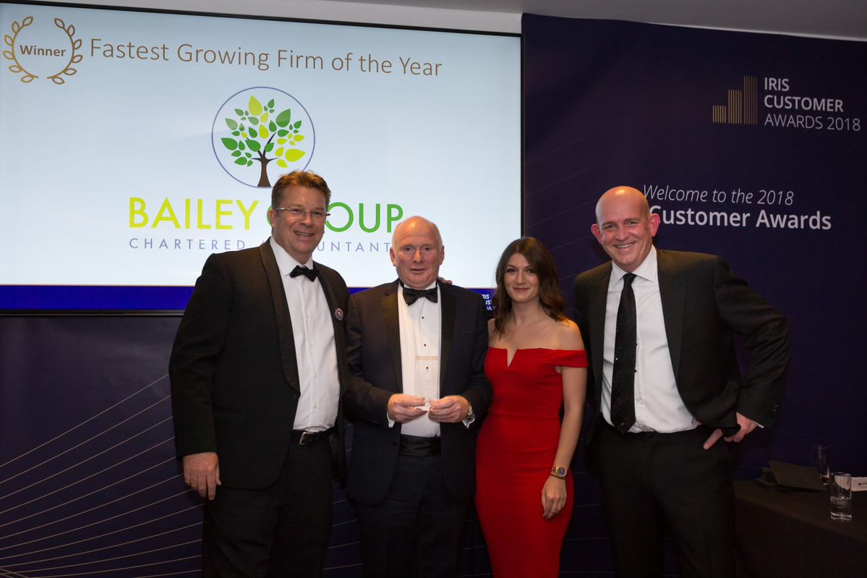

We’d like congratulate Less Tax 4 Landlords co-founder Chris Bailey and all of his team at The Bailey Group for their well earned recognition at the IRIS Customer Awards.
On the 9th October 2018 at Twickenham Stadium, leading figures from the accountancy industry toasted the success of firms working with IRIS at a glittering ceremony in London, with Bailey Group Chartered Accountants winning the ‘Fastest Growing Firm of the Year.’
The IRIS Software Group, who are the largest privately held software company in the UK, celebrated their 40th year in business by hosting an awards ceremony that recognised best practice across a wide range of areas.
The Bailey Group were incredibly proud to be amongst the 13 winners on the night with the judges noting that, “the growth displayed by Bailey Group Chartered Accountants was nothing short of first-class. Not only did they display impressive growth in client numbers and fee income, they have continued to retain customers at an impressive rate and expand the business significantly.”

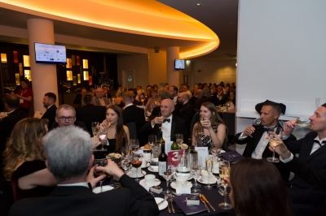
https://www.iris.co.uk/insight/news/2018/elated-iris-customers-celebrate-victory-at-first-ever-awards-night/

Twitter post
Chris Bailey of the The Bailey Group had an excellent evening at the #IRISawards ceremony last week, walking away with the ‘Fastest Growing Firm of the Year’ award. Thanks to @IRISAccountants for a great evening.
https://t.co/2oGriVtgzV

